**[118] Programming Lab 4**

Haoyu Wang

Monday

October 09, 2017

**Lab 4 Code**

1. // Programming Lab 04 - 10/09/2017
2. // written by Haoyu Wang
3. #include "library.h"

6. **const** **double** PI = acos(-1.0);
8. **void** boom(**double** posx, **double** posy, **int** length)
9. {
11. **int** y = length;
12. **int** z = length * 2;
14. start_shape(); // SHAPE
15. move_to(posx,posy);
16. note_position();  // Shape
17. set_heading_degrees(0);
18. turn_left_by_degrees(90); // changing the direction to to 270
19. draw_distance(y);
20. note_position();  // Shape
21. set_heading_degrees(-60);
22. draw_distance(y);
23. note_position();  // Shape
24. set_heading_degrees(90);
25. draw_distance(3/2.0 *y);
26. note_position();  // Shape
27. set_heading_degrees(-30);
28. draw_distance(y);
29. note_position();  // Shape
30. set_heading_degrees(120);
31. draw_distance(y);
32. note_position();  // Shape
33. set_heading_degrees(20);
34. draw_distance(y);
35. note_position();  // Shape
36. set_heading_degrees(160);
37. draw_distance(y);
38. note_position();  // Shape
39. set_heading_degrees(30);
40. draw_distance(y);
41. note_position();  // Shape
42. set_heading_degrees(140);
43. draw_distance(y);
44. note_position();  // Shape
45. set_heading_degrees(60);
46. draw_distance(y);
47. note_position();  // Shape
48. set_heading_degrees(180);
49. draw_distance(2/3.0 * y);
50. note_position();  // Shape
51. set_heading_degrees(60);
52. draw_distance(y);
53. note_position();  // Shape
54. set_heading_degrees(200);
55. draw_distance(y);
56. note_position();  // Shape
57. set_heading_degrees(110);
58. draw_distance(y);
59. note_position();  // Shape
60. set_heading_degrees(260);
61. draw_distance(2.5/2.0 *y);
62. note_position();  // Shape
63. set_heading_degrees(130);
64. draw_distance(3/2.0 *y);
65. note_position();  // Shape
66. set_heading_degrees(290);
67. draw_distance(y);
68. note_position();  // Shape
69. set_heading_degrees(180);
70. draw_distance(y);
71. note_position();  // Shape
72. set_heading_degrees(-60);
73. draw_distance(y);
74. note_position();  // Shape
75. set_heading_degrees(200);
76. draw_distance(y);
77. note_position();  // Shape
78. set_heading_degrees(-30);
79. draw_distance(y);
80. note_position();  // Shape
82. set_heading_degrees(220);
83. draw_distance(y);
84. note_position();  // Shape
85. set_heading_degrees(-30);
86. draw_distance(2.5/2 * y);
87. note_position();  // Shape
89. set_heading_degrees(250);
90. draw_distance(y);
91. note_position();  // Shape
92. set_heading_degrees(20);
93. draw_distance( y);
94. note_position();  // Shape
96. set_heading_degrees(260);
97. draw_distance(y);
98. note_position();  // Shape
99. set_heading_degrees(30);
100. draw_distance(0.75 * y);
101. note_position();  // Shape
102. set_pen_color(color::orange);
103. fill_shape();
105. //Draw Edges
106. move_to(posx,posy);
107. set_pen_color(color::red);
108. set_pen_width(2);
109. set_heading_degrees(0);
110. turn_left_by_degrees(90);
111. move_distance(y);
112. set_heading_degrees(-60);
113. draw_distance(y);
114. set_heading_degrees(90);
115. draw_distance(3/2.0 *y);
116. set_heading_degrees(-30);
117. draw_distance(y);
118. set_heading_degrees(120);
119. draw_distance(y);
120. set_heading_degrees(20);
121. draw_distance(y);
122. set_heading_degrees(160);
123. draw_distance(y);
124. set_heading_degrees(30);
125. draw_distance(y);
126. set_heading_degrees(140);
127. draw_distance(y);
128. set_heading_degrees(60);
129. draw_distance(y);
130. set_heading_degrees(180);
131. draw_distance(2/3.0 * y);
132. set_heading_degrees(60);
133. draw_distance(y);
134. set_heading_degrees(200);
135. draw_distance(y);
136. set_heading_degrees(110);
137. draw_distance(y);
138. set_heading_degrees(260);
139. draw_distance(2.5/2.0 *y);
140. set_heading_degrees(130);
141. draw_distance(3/2.0 *y);
142. set_heading_degrees(290);
143. draw_distance(y);
144. set_heading_degrees(180);
145. draw_distance(y);
146. set_heading_degrees(-60);
147. draw_distance(y);
148. set_heading_degrees(200);
149. draw_distance(y);
150. set_heading_degrees(-30);
151. draw_distance(y);
152. set_heading_degrees(220);
153. draw_distance(y);
154. set_heading_degrees(-30);
155. draw_distance(2.5/2 * y);
156. set_heading_degrees(250);
157. draw_distance(y);
158. set_heading_degrees(20);
159. draw_distance( y);
160. set_heading_degrees(260);
161. draw_distance(y);
162. set_heading_degrees(30);
163. draw_distance(0.75 * y);
165. set_pen_color(color::red);
166. move_to(posx+(length),posy);
167. set_font_size(length+ length/4);
168. write_string("BOOM!",direction::center);
169. set_font_size(0);
171. set_pen_width(2);
172. set_pen_color(color::black);
173. set_heading_degrees(0);
175. }
177. **void** cannonWheel(**const** **double** r, **const** **double** N, **int** shaped, **const** **double** size)
178. {
179. **if**(N<=0)
180. {
181. set_pen_color(color::black);
182. set_pen_width(5);
183. draw_point();
184. set_pen_width(1);
185. }
186. **else**
187. {
188. set_pen_width(size);
189. set_pen_color(color::black);
190. move_distance(r);
191. draw_point();
192. **if**(shaped==1)
193. note_position();
194. move_distance(-r);
195. turn_right_by_degrees(1);
196. **if**(shaped==1)
197. cannonWheel(r,N-1,1,size);
198. **else**
199. cannonWheel(r,N-1,0,size);
200. }
202. }
204. **double** cannonBody(**const** **double** r, **const** **double** angle)
205. {
206. set_pen_width(2);
207. **const** **double** L1 = 1.4*r;
208. **const** **double** L2 = 4.0*r;
209. **const** **double** L3 = L1+L2;
210. **const** **double** W1 = 2.0*r;
211. **const** **double** W2 = 1.4*r;
213. **const** **double** b = ( asin((W1-W2)/2/(L1+L2)) ) * 180 / PI;
215. **const** **double** cX = get_x_position(); // the position of the center of wheel C
216. **const** **double** cY = get_y_position();
217. **const** **double** gY = get_y_position()+r;
219. set_heading_degrees(180+90-angle);
221. move_distance(L1);
222. **const** **double** pX = get_x_position();
223. **const** **double** pY = get_y_position();
224. move_distance(-L1);
226. **if** (pY > gY) // to make sure P can't be bellow ground level
227. {
228. print("ERROR! At angle : ");
229. print( angle-b );
230. print(" | gY : ");
231. print( gY );
232. print(" | pY : ");
233. print( pY );
234. print("\t.. trying a lower angle.");
235. new_line();
236. **return** cannonBody(r,angle-1);
237. }
239. set_pen_color(color::white);
240. draw_distance(r);
241. set_pen_color(color::black);
242. draw_distance(L1-r);
244. start_shape();
245. note_position(); //1
247. turn_right_by_degrees(93);
248. draw_distance(W1/2.0);
250. **const** **double** w1X = get_x_position(); // getting the position of the center of W1
251. **const** **double** w1Y = get_y_position();
253. draw_distance(W1/2.0);
255. note_position(); //2
257. turn_right_by_degrees(93);
258. draw_distance(L3);
260. note_position(); //3
262. turn_right_by_degrees(87);
263. draw_distance(W2/2.0);
265. **const** **double** eX = get_x_position(); // getting the position of the center of W2
266. **const** **double** eY = get_y_position();
268. draw_distance(W2/2.0);
270. **const** **double** posX = get_x_position();
271. **const** **double** posY = get_y_position();
273. note_position(); //4
274. set_pen_color(color::light_grey);
275. fill_shape();
277. //Coloring Cannon Head
278. set_pen_color(color::black);
279. turn_right_by_degrees(87);
281. start_shape();
282. note_position(); //1
283. move_distance(L3/10);
284. **const** **double** p1bX = get_x_position();
285. **const** **double** p1bY = get_y_position();
286. move_distance(L3/10);
287. **const** **double** p2bX = get_x_position();
288. **const** **double** p2bY = get_y_position();
289. move_distance(L3/10);
290. **const** **double** p3bX = get_x_position();
291. **const** **double** p3bY = get_y_position();
292. note_position(); //2
294. move_distance( L3 - 3*(L3/10) );
295. turn_right_by_degrees(93);
296. move_distance(W1);
297. turn_right_by_degrees(93);
299. move_distance( L3 - 3*(L3/10) );
300. note_position(); //3
301. **const** **double** p3tX = get_x_position();
302. **const** **double** p3tY = get_y_position();
303. move_distance(L3/10);
304. **const** **double** p2tX = get_x_position();
305. **const** **double** p2tY = get_y_position();
306. move_distance(L3/10);
307. **const** **double** p1tX = get_x_position();
308. **const** **double** p1tY = get_y_position();
309. move_distance(L3/10);
310. note_position(); //4
311. set_pen_color(color::grey);
312. fill_shape();
314. //Lining Cannon Head
315. set_pen_width(1);
316. set_pen_color(color::black);
317. move_to(p1tX,p1tY);
318. draw_to(p1bX,p1bY);
319. move_to(p2bX,p2bY);
320. draw_to(p2tX,p2tY);
321. move_to(p3tX,p3tY);
322. draw_to(p3bX,p3bY);
324. turn_right_by_degrees(87);
325. move_to(posX,posY);
327. //Lining the Canon
328. set_pen_width(1.5);
329. set_pen_color(color::black);
330. turn_right_by_degrees(87);
331. draw_distance(L3);
332. turn_right_by_degrees(93);
333. draw_distance(W1);
334. turn_right_by_degrees(93);
335. draw_distance(L3);
336. turn_right_by_degrees(87);
337. draw_distance(W2);
338. //----------------
340. turn_right_by_degrees(87);
341. draw_distance(L2-r);
342. set_pen_color(color::white);
343. draw_distance(r);
344. set_pen_color(color::black);
346. move_to(cX,cY);
347. start_shape();
348. cannonWheel(r, 360, 1, 2.5);
349. set_pen_color(color::grey);
350. fill_shape();
351. cannonWheel(r, 360, 0, 2.5);
352. cannonWheel(r/2, 360, 0, 1.5);
354. move_to(eX,eY);
355. set_heading_degrees(90-angle);
356. **return** angle;
357. }
359. **int** cannon(**const** **double** v, **const** **double** ground, **const** **double** enemy_size, **const** **double** enemy_pos, **const** **double** angle, **const** **double** t = 0)
360. {
361. **if** ( (get_x_position() >= enemy_pos-enemy_size) && ( get_x_position() <= (enemy_pos - enemy_size/8) ) && (get_y_position() >= ground-enemy_size) && (get_y_position() <= ground) )
362. {
363. print("The cannon hits the enemy after ");
364. print(t);
365. print(" seconds!\n");
366. boom(get_x_position()-10,get_y_position(),15);
367. set_pen_color(color::black);
368. **return** 1;
369. }
370. **else** **if** ( get_y_position() >= ground )
371. {
372. print("The cannon touches the ground after ");
373. print(t);
374. print(" seconds.\n");
375. set_pen_color(color::black);
376. **return** 0;
377. }
378. **else**
379. {
380. set_pen_width(2);
381. **const** **double** h =  ( v * t * cos( (90-angle)*PI/180) ) - ( 0.5 * 9.807 * pow( t ,2) );
382. **const** **double** d =  ( v * t * sin( (90-angle)*PI/180) );
383. **const** **double** x = get_x_position()+d/60;
384. **const** **double** y = get_y_position()-h/60;
385. set_pen_color(250+t*31);
386. wait(1.0/1000);
387. draw_to(x,y);
388. //cout << "\n * Time " << t;
389. set_pen_width(1);
390. cannon(v, ground, enemy_size, enemy_pos, angle, t+1.0/60);
391. }
392. }
394. **void** draw_ground(**const** **double** gY,**const** **double** originalG, **const** **int** n=0)
395. {
396. **if** ( get_x_position() >= get_window_width() && get_y_position() >= get_window_height() )
397. {
398. set_pen_color(color::black);
399. move_to(0.0, originalG+1);
400. draw_to((**float**)get_window_width(), originalG+1);
401. set_pen_width(2);
402. **return**;
403. }
404. **else**
405. {
406. set_pen_color(color::light_grey+n*3.5);
407. set_pen_width(1);
408. move_to(0.0, gY+1);
409. draw_to((**float**)get_window_width(), gY+1);
410. draw_ground(gY+1,originalG,n+1);
411. }
412. }

415. **double** draw_enemy(**const** **double** ground_point_y)
416. {
417. set_pen_width(1);
418. set_heading_degrees(0);
419. **const** **double** x = (**double**)random_in_range(600,1000);
420. **const** **double** size = (**double**)random_in_range(40,100);
421. **double** positionX, positionY;
423. //Drawing Level 1
424. start_shape();
425. move_to(x,ground_point_y);
426. draw_distance(size/2);
427. note_position(); //1
428. positionX = get_x_position();
429. positionY = get_y_position();
430. set_heading_degrees(-90);
431. draw_distance(size);
432. note_position(); //2
433. set_heading_degrees(180);
434. draw_distance(size/2);
435. note_position(); //3
436. set_heading_degrees(90);
437. move_distance(size);
438. note_position(); //4
439. set_pen_color(color::grey);
440. fill_shape();
441. //Coloring Level 1
442. start_shape();
443. move_to(positionX,positionY);
444. set_heading_degrees(-90);
445. note_position(); //1
446. set_heading_degrees(-90);
447. draw_distance(size);
448. note_position(); //2
449. set_heading_degrees(180);
450. draw_distance(size/2);
451. note_position(); //3
452. set_pen_color(color::dark_grey);
453. fill_shape();
454. set_pen_color(color::black);
455. move_to(positionX,positionY);
456. set_heading_degrees(-90);
457. draw_distance(size);
458. set_heading_degrees(180);
459. draw_distance(size/2);
460. set_heading_degrees(90);
461. move_distance(size);
462. set_heading_degrees(0);
463. draw_distance(size/2);
464. //Drawing Level 2
465. start_shape();
466. move_to(positionX,positionY);
467. set_heading_degrees(-90);
468. draw_distance(size/4);
469. note_position(); //1
470. set_heading_degrees(0);
471. draw_distance(size/2);
472. note_position(); //2
473. set_heading_degrees(-90);
474. draw_distance(size/4);
475. positionX = get_x_position();
476. positionY = get_y_position();
477. draw_distance(size/4);
478. note_position(); //3
479. set_heading_degrees(180);
480. draw_distance(size/2);
481. note_position(); //4
482. set_pen_color(color::grey);
483. fill_shape();
485. //Coloring Level 2
486. move_to(positionX+size/4,positionY);
487. start_shape();
488. note_position(); //1
489. set_heading_degrees(-90);
490. draw_distance(size/2);
491. note_position(); //2
492. set_heading_degrees(180);
493. draw_distance(size/2);
494. note_position(); //3
495. set_pen_color(color::dark_grey);
496. fill_shape();
498. set_pen_color(color::black);
499. move_to(positionX+size/4,positionY);
500. set_heading_degrees(-90);
501. draw_distance(size/2);
502. set_heading_degrees(180);
503. draw_distance(size/2);
504. set_heading_degrees(90);
505. draw_distance(size/2);
506. set_heading_degrees(0);
507. draw_distance(size/2);
509. //Flag
510. move_to(positionX,positionY);
511. set_heading_degrees(0);
512. draw_distance(size/2);
514. //Drawing Flag
515. start_shape();
516. note_position(); //1
517. turn_right_by_degrees(90);
518. draw_distance(size/4);
519. note_position(); //2
520. turn_right_by_degrees(90);
521. draw_distance(size/8);
522. note_position(); //3
523. turn_right_by_degrees(90);
524. draw_distance(size/4);
525. note_position(); //4
526. set_pen_color(color::dark_red);
527. fill_shape();
529. set_pen_color(color::black);
530. turn_right_by_degrees(90);
531. draw_distance(size/8);
532. turn_right_by_degrees(90);
533. draw_distance(size/4);
534. turn_right_by_degrees(90);
535. draw_distance(size/8);
536. turn_right_by_degrees(90);
537. draw_distance(size/4);
538. move_to(x,ground_point_y);
539. **return** size;
540. }
542. **void** game_message(**int** x, **int** y, string message, **int** color=0)
543. {
544. **const** **double** original_x = get_x_position();
545. **const** **double** original_y = get_y_position();
546. move_to(x,y);
547. **if**(color==1)
548. set_pen_color(color::dark_green);
549. **if**(color==2)
550. set_pen_color(color::dark_red);
551. write_string(message);
552. move_to(original_x,original_y);
553. set_pen_color(color::black);
554. }
556. **void** game_message2(string message, **int** size, **int** color)
557. {
558. **const** **double** original_x = get_x_position();
559. **const** **double** original_y = get_y_position();
561. start_shape();
562. move_to( 200, 110 );
563. note_position();
564. draw_to( 800, 110 );
565. note_position();
566. draw_to( 800, 310 );
567. note_position();
568. draw_to( 200, 310 );
569. note_position();
570. draw_to( 200, 110 );
571. note_position();
573. **if**(color==0)
574. set_pen_color(color::light_grey-90);
576. **if**(color==1)
577. set_pen_color(color::green);
579. **if**(color==2)
580. set_pen_color(color::dark_red);
582. fill_shape();
583. set_pen_color(color::black);
585. move_to( 200, 110 );
586. draw_to( 800, 110 );
587. draw_to( 800, 310 );
588. draw_to( 200, 310 );
589. draw_to( 200, 110 );
591. move_to(500,210);
592. set_font_size(size);
593. write_string(message,direction::center);
594. move_to(original_x,original_y);
595. set_font_size(0);
596. **return**;
597. }

600. **void** main()
601. {
602. make_window(1000,600);
603. set_pen_width(3);
604. move_to(50,500);
606. **char** run = 'Y';
607. **double** r = 20;
608. **double** angle, velocity, enemy_size, enemy_position, eX, eY;;
609. **double** cX = get_x_position();
610. **double** cY = get_y_position();
611. **double** ground = cY+r;
613. print("Lab 4 - Cannon Game\nMade By Haoyu Wang");
614. print("\n------------------------------------------------------------------------------\n");
615. print("This game presents an enemy of a random size and a random position in the area.\n");
616. print("Choose the angle of the cannon, and the velocity to hit your target.\n");
617. print("\n==============================================================================\n");
619. **while** ( run == 'Y' || run =='y' )
620. {
621. clear();
622. move_to(10,20);
623. write_string("Lab 4 - Cannon Game");
624. move_to(210,30);
625. draw_to(10,30);
627. draw_ground(ground,ground);
628. enemy_size = draw_enemy(ground);
629. enemy_position = get_x_position();
630. move_to(cX,cY);
632. print("Enter the angle (degrees) = ");
633. angle = read_float();
634. angle = cannonBody(r, angle);
635. eX = get_x_position();
636. eY = get_y_position();
638. print("\nYou have three chances to hit the enemy!");
639. print("\nATTEMPT NUMBER 1");
640. game_message(10,50,"Attempt 1:");
641. print("\nEnter the velocity (metres per second) = ");
642. move_to(eX,eY);
643. velocity = read_float();
645. **if**( cannon(velocity,ground,enemy_size,enemy_position,angle) == 1)
646. {
647. game_message(110,50,"Congratulations! You hit the target!",1);
648. game_message2("You Win!",100,1);
649. }
650. **else**
651. {
652. game_message(110,50,"You missed the target.",2);
653. print("\nATTEMPT NUMBER 2");
654. game_message(10,70,"Attempt 2:");
655. print("\nEnter the velocity (metres per second) = ");
656. move_to(eX,eY);
657. velocity = read_float();
659. **if**( cannon(velocity,ground,enemy_size,enemy_position,angle) == 1)
660. {
661. game_message(110,70,"Congratulations! You hit the target!",1);
662. game_message2("You Win!",100,1);
663. }
664. **else**
665. {
666. game_message(110,70,"You missed the target.",2);
667. print("\nATTEMPT NUMBER 3");
668. game_message(10,90,"Attempt 3:");
669. print("\nEnter the velocity (metres per second) = ");
670. move_to(eX,eY);
671. velocity = read_float();
673. **if**( cannon(velocity,ground,enemy_size,enemy_position,angle) == 1)
674. {
675. game_message(110,90,"Congratulations! You hit the target!",1);
676. game_message2("You Win!",100,1);
677. }
678. **else**
679. {
680. game_message(110,90,"That's too bad. You missed the last shot.",2);
681. game_message2("Game Over",100,2);
682. }
683. }
684. }
685. print("\n\nDo you want to play again? (type y or Y to play again, anything else to quit) ");
686. cin >> run;
687. print("\n==============================================================================\n");
688. }
689. clear();
690. game_message2("Thanks for playing!",70,0);
691. **return**;
693. }

The program produces an enemy of a random shape, and a random location. The user gets to choose the angle of the cannon, then three chances to pick the right velocity to hit the enemy. If at any point the enemy gets hit, the game ends with the user winning, if not: game over. Then the user gets the option to play again.

The console will show the time of each cannon when it hits the ground or the target.

**Result (Win from the first try)**

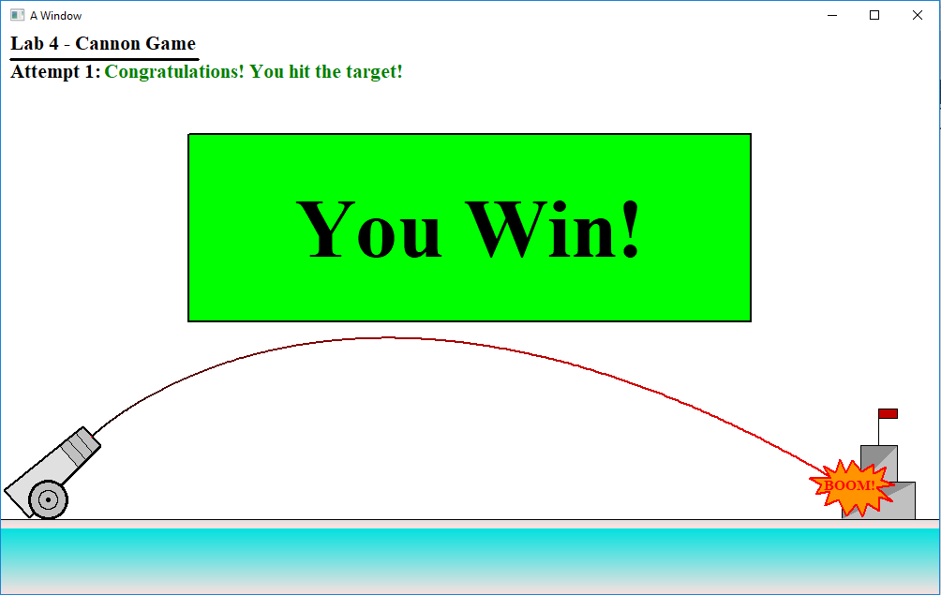

**Result (Win from the second try)**

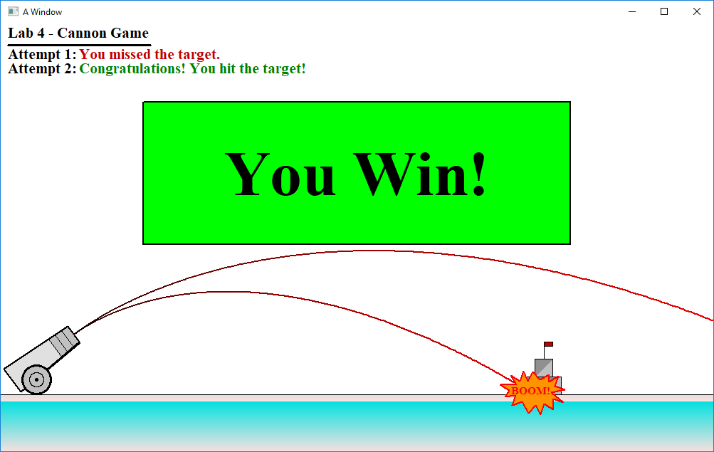

**Result (Win from the third try)**

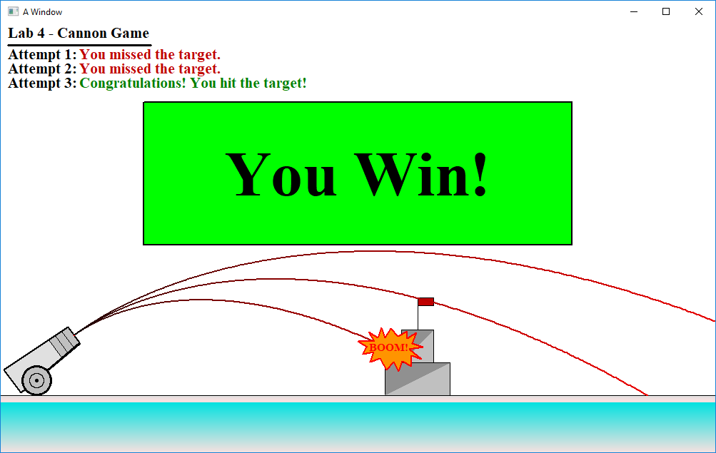

**Result (Loss after three tries)**

